Name of the Faculty: VINEETA CHAUDHARY
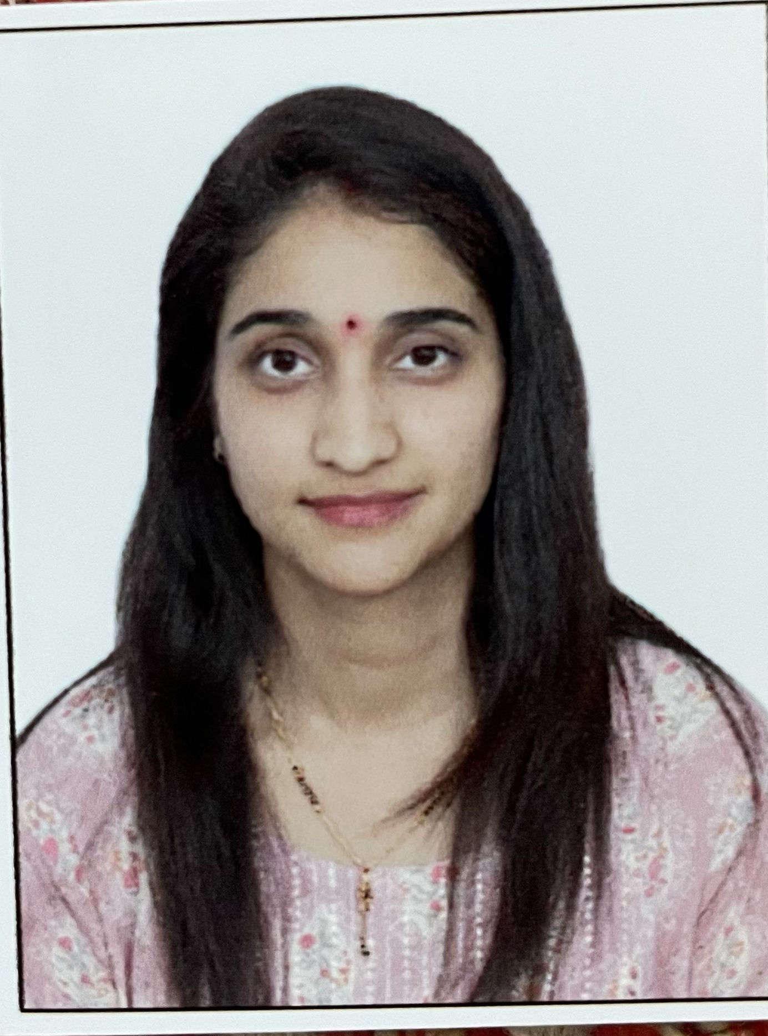 | Designation: ASSISTANT PROFESSOR  Department: COMMERCE
Education: B.COM FROM UNIVERSITY OF DELHI
M.COM FROM INDIRA GANDHI NATIONAL OPEN UNIVERSITY
Contact info:  Mobile: 8745003443  Email id: vineeta.chaudhary12@gmail.com | Areas of Interest  Teaching: BUSINESS ORGANIZATION AND MANAGEMENT  HUMAN RESOURCE MANAGEMENT  ORGANIZATIONAL BEHAVIOUR  Research: TOPICS RELATED WITH E-COMMERCE
Subjects Taught:

BUSINESS ORGANIZATION AND MANAGEMENT
ORGANIZATIONAL BEHAVIOUR
ADVERTISING AND PERSONAL SELLING
HUMAN RESOURCE MANAGEMENT

Publications:
External influences Effect on young consumers buying actions with respect to apparel industry in Delhi city. International Research Journal of Management and Commerce ISSN: (2348-9766) Impact Factor 7.001 Volume 9, Issue 03 March 2022
A study for Indian Consumers depicting significant impact of Consumer Trust on their online purchasing habits. INTERNATIONAL RESEARCH JOURNAL OF COMMERCE, ARTS AND SCIENCE ISSN: (2319 – 9202) Volume 13 Issue 7 [Year - 2022]
A study on the impact of pandemic of consumer behaviour INTERNATIONAL RESEARCH JOURNAL OF COMMERCE, ARTS AND SCIENCE ISSN: (2319 – 9202) Volume 13 Issue 6 June 2022

Conferences-Seminars Presentations and Participations: Participated in “How to Become a Successful Entrepreneur – Atamnirbhar” organized by School of Open Learning, University of Delhi, From 28 May, 2020 to 08 June, 2020.
Participated in The Vision and Mission of Bharat Ratna Dr. B. R. Ambedkar for a Better Society, Nation and World” held on 15th May 2020 hosted by Internal Quality Assurance Cell in association with S.C. S.T & O.B.C. Cell Delhi college of Arts & Commerce.
Participated in Awareness Session for Financial & Retirement Solution” held on 11th May 2020 hosted by Internal Quality Assurance Cell Delhi college of Arts & Commerce in association with Bajaj Capital Limited .
Participated in Digital Transformation with Robotic Process Automation In association with Automation Anywhere conducted on 8-May-2020.
Participated in The Way to Total Well-Being” held on 5th May 2020 hosted by Internal Quality Assurance Cell Delhi college of Arts & Commerce in association with Bajaj Capital Limited .
Participated in Revitalising Psychological & Physical Well Being During Lockdown" organised by Department of Commerce, Sri Aurobindo College under the aegis of IQAC on 27 April, 2020
Participated in Coronavirus pandemic: challenges opportunities and road ahead by research and consultancy cell PGDAV college.

Any Other (as per requirement)
Net Exam in 2017
Pursuing Ph.D on “ STUDY OF SURGING DEMAND IN E-COMMERCE INDUSTRY AND IT'S ROLE IN THE INDIA'S GROWTH FOLLOWING IT'S TREND EFFECTS ON RURAL POPULATION”

