SURBHI
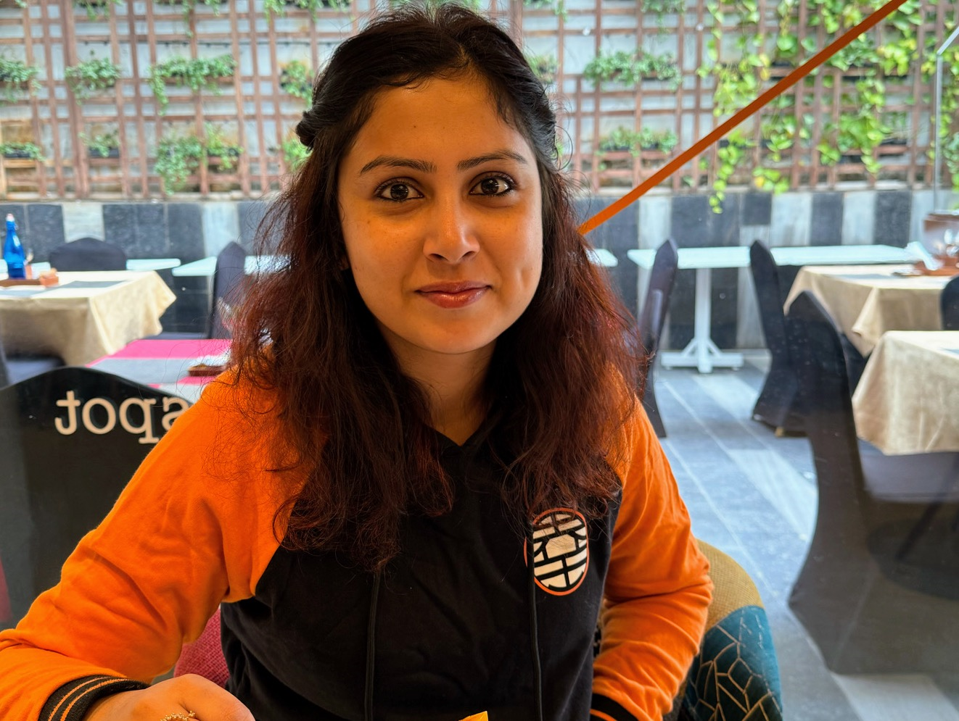 | Assistant Professor, Member of Counseling and Mental Health Awareness Cell, Department of Applied Psychology, Ramanujan College, University of Delhi, Kalkaji, New Delhi-110019  Academic Counselor at IGNOU
- Pursuing PhD in Cognitive Psychology
- Qualified NET-Lectureship in 2014
- Diploma in Community Mental Health for Psychologists from NIMHANS Digital Academy, Bangalore (2021)
- Post- Graduation(2015): M.A. Psychology, Faculty of Arts (North Campus), Department of Psychology, University of Delhi
- Graduation (2013): B.A. (Hons.) Applied Psychology, Vivekananda College, University of Delhi
Contact info  Mobile: 9873346906, 8630083191  Email: gautamsurbhi1@gmail.com  gautamsurbhi39@gmail.com | AREAS OF INTEREST:  Counseling Psychology, Neuropsychology, Clinical Psychology, Industrial Psychology, Research Methods
SUBJECTS TAUGHT:

Counseling Psychology, Clinical Psychology, Systems in Psychology, Stress Management, Developmental Psychology, Research Methods, Group Processes, Introduction to Psychology, Biopsychology, Understanding Psychological Disorders

CONFERENCES-SEMINARS PRESENTATIONS AND PARTICIPATIONS

• (December 2018) Presented Research Paper on “Cultural Influence on Object Localization: A Literature Review” at National Academy of Psychology at University of Delhi, Delhi
• (December 2018) Presented Research Paper on “Perspectives on Euthanasia and Living Will” at National Academy of Psychology at University of Delhi, Delhi
• (February 2017) Presented Research Paper on “Movie Analysis for Understanding Sports Psychology in India” at International Conference of Indian Academy of Applied Psychology at University of Rajasthan
• (September 2016) Presented Poster on “Values and Beliefs among the generations” at National Conference at Mata Sundri College for Women, University of Delhi
• (September 2016) Presented Research Paper on “Intergenerational Conflict and Stress” at National Conference at Mata Sundri College for Women, University of Delhi
• (April 2016) Presented Research Paper on “Social Representation of God in Hinduism” at International Conference at Ramanujan College, University of Delhi
PUBLICATIONS

- Kumar A., Misra I, Surbhi. Hemispheric Lateralization for Processing Emotional Stroop Like Task Among Right and Non- Right Handers. Journal of Positive School Psychology. Volume 6, Issue 8. Page No. 3515- 3525 (August,2022)
- Tiwari D.N, Kumar Ashwini, Surbhi, Nayan R., Pandey A.R. Primed Orientation (Self and Other) and Life Satisfaction: Examining Coping Strategies as the Mediator and Education as the Moderator across Indo-Pakistan Border. Journal of Positive School Psychology. Volume 6. Issue 6. Page no. 10243-10255. 2022 (August, 2022)
- Yadav N, Kumar Ashwini & Surbhi. Comprehending Psychological Impact on Students During Lockdown. Bulletin of Environment, Pharmacology and Life Sciences (Special Issue) 2022. Volume 1 (April,2022)
- Surbhi, A. Kumar & N. Yadav. Hidden Power of Being Simple: Learnings During Covid 19. Vidyabharati International Interdisciplinary Research Journal (Special Issue) Part 9.Page No. 1276. ISSN No. 2319-4979 (September,2021)
- Surbhi, N. Yadav & A. Kumar. Orientation towards Environmental Change and its relation with Mental Health during Covid-19 Pandemic. Turkish Online Journal of Qualitative Inquiry. Volume 12. issue 01, January 2021, 218-237 (January,2021)
- Chapter on “An Exploratory Study to Analyze the Impact of COVID-19 on the Daily Lives of People: A Focus Group Discussion” in Health Informatics and Technological Solutions for Coronavirus (Covid-19). Taylor and Francis Group. ISBN: 9780367704179 (hbk) ISBN: 9780367751210 (pbk) ISBN: 9781003161066 (ebk) (June,2021)
- Chapter on “Stress and Stress Management” in the book “Guidance and Counseling”. ISBN NO. 978-81-945153-4-0
- Tamanna Tiwari, Suniti, Ashapurna Das & Surbhi. Perspective on Euthanasia and Living Will. Journal of the Gujarat Research Society. Volume 21 Issue 10
- Nirupuma Yadav & Surbhi. Hypnotherapy as an Emerging Field or an alternative treatment in the field of therapy. International Journal of Higher Education and Research. Volume (10) ISSN: 2277-260X
- Tamanna Tiwari, Suniti, Ashapurna Das & Surbhi. Euthanasia: Review. Think India Journal . ISSN: 0971-1260
- Chapter on “Participatory Role of Teacher in Special Education” in the book “Special Education: Issues and Challenges” ISBN NO. : 978-81-942110-4-4
- Chapter on “Cognizance of Language and its Components: Listening, Understanding, Speaking, Reading and Writing Skill” in the book “Pedagogy of English” ISBN No.: 978-81-940502-9-2
- Shikha Golcha & Surbhi (2019). Movie Analysis for Understanding Sports Psychology in India. International Journal of Research and Analytical Reviews
- Surbhi, Nirupama Yadav & Dr. Ashwini Kumar (2019). Role of God and Religion in Healing in Post-Disaster Settings. International Journal of Scientific Research and Reviews
TEACHING EXPERIENCE

- (August 2021- December 2021) Worked as Guest Lecturer at Deen Dayal Kaushal Kendra, Ramanujan College, University of Delhi
- (August 2019- Present) Working as Faculty Member, Counseling Cell, Department of Applied Psychology, Ramanujan College, University of Delhi
- (January 2019- Present) Working as Assistant Professor at Department of Applied Psychology, Ramanujan College, University of Delhi
- (January 2017- Present) Working as Academic Counselor at Indira Gandhi National Open University, Delhi
- (August 2017- July 2019) Worked as Counseling Psychologist at Ramanujan College, University of Delhi
- (July 2017- November 2018) Worked as Guest Lecturer at Department of Applied Psychology, Ramanujan College, University of Delhi
- (July 2018- December 2018) Worked as Guest Lecturer at Deen Dayal Kaushal Kendra, Ramanujan College, University of Delhi
- (January 2018- April 2018) Worked as Guest Lecturer at Department of Psychology, Rajguru College of Applied Sciences, University of Delhi
- (September 2016 – November 2016) Worked as Guest Lecturer at Department of Psychology, Jesus and Mary College, University of Delhi
- (January 2016- April 2016) Worked as Guest Lecturer at Department of Applied Psychology, Ramanujan College, University of Delhi
WORKING EXPERIENCE (APART FROM TEACHING)
- Invited as Guest Speaker for topic “Mental Health: Let’s do it” for a session on 9 June 2023 at the Add on Certificate Training Course in Guidance and Counseling organized by Lakshmibai College, University of Delhi
- Invited as Guest Speaker for topic “Move for Mental Health” for a session on 29 October 2022 organized by Jindal Global Business School
- Invited as Guest Speaker for topic “ Need for Mental Health” for a session on 20th October 2022 for a project of TISS
- Invited as Guest Speaker for topic on “Mental Health Awareness” for a session on 15th July 2022 organized by Department of Commerce, Ramanujan College, University of Delhi
- ​​Invited for lecture on “Scope of Counseling” for a session on 9 June 2022 at the Add on Certificate Training Course in Guidance and Counseling organized by Lakshmibai College, University of Delhi
- Invited as Resource Person by Sushant University to speak on topic “Mental Health in Times of Covid 19 and beyond” on (July 15, 2021)
- (May 2017- June 2017) Internship at Department of Psychiatry and Drug De- Addiction Center, Lady Hardinge Medical College & Smt. S.K. Hospital, New Delhi
- (October 2015 - January 2016) Research Assistant at Project “Social Networks affect human pair choice in different populations” at Department of Experimental Psychology, Oxford University
- (September 2015- February 2016) Worked as Counselor at Hope Network and www.LocalOye.com
- (June 2014 – August 2014) Worked as Intern in National Mission On Education(NMEI) and University Grants Commission(UGC) Project

ACADEMIC WORK

- (August 2020) Organized Webinar on “Enhancing Psychological Skills for Teaching and Practice”
- (May 2020) Organized Webinar on “Stress Management during Quarantine”, Student Welfare Committee, Ramanujan College, University of Delhi
- (October 2019) Organized “Mental Health Awareness Campaign for Suicide Prevention” for students of Ramanujan College, University of Delhi
- (September 2019) Organized National Seminar on “Globalization, Diversity and Equality: Challenges for Indian Society”, Ramanujan College, University of Delhi
- (December 2018) Worked as part of Organizing Committee in “National Academy of Psychology” 2019 organized by Department of Applied Psychology, Ramanujan College, University of Delhi
- (April 2016) Worked as part of Organizing Committee in International Conference on “Indian Mind and Societal Concerns: An Interdisciplinary Dialogue”, Ramanujan College, University of Delhi
ACHIEVEMENTS

- Completed Faculty Development Programme on “Online Refresher Course in Psychology” organized by Teaching Learning Center and Center for Psycho-Social Resource Development and Training, Ramanujan College, university of Delhi (April, 2021)
- Attended workshop on “Coding Qualitative Data using NVivo” (July, 2020)
- Participated in Online Interactive Training Webinar on “Cognitive Behavioral Therapy :Applied in Indian Settings” (May 2020)
- Completed Beginners Level in “Drawing and Doodle Analysis” by Posity (May 2020)
- Participated in Live webinar on “Understanding Tele-Counseling” by Department of Psychology, Patrician College of Arts and Science, Tamil Nadu (May, 2020)
- Completed Faculty Development Programme on “Managing Online Classes and Co-Creating MOOCs” organized by Ramanujan College, University of Delhi, Delhi (May, 2020)
- Completed WHO Certification for “COVID- 19: Operational Planning Guidelines and COVID-19 Partners Platform to support Country Preparedness and response” (May, 2020)
- Completed Faculty Development Programme on “Teachers, Teaching, and Taught: Discovering new Meanings, Relationships, and Purpose” organized by Ramanujan College, University of Delhi, Delhi (January, 2020)
- Completed “Level one – An introduction to Clinical Hypnosis” certified by California Hypnosis Institute, California, USA
- Recipient of “University Post Graduate Scholarship” (2013-2015)
- 3rd POSITION HOLDER in “University of Delhi”(2010-2013)
- 1st POSITION HOLDER in “Vivekananda College, University of Delhi” consecutively for two years(2011-2013)
- Won SECOND POSITION in Power Point Presentation Competition in Vivekananda College, UNIVERSITY OF DELHI” (2013)
- Recipient of “GEETIKA NAGPAL KHURANA SCHOLARSHIP” and “NAMAN AHLUWALIA SCHOLARSHIP” for academic excellence (2012-2013)
- Won first position in English POETRY in Vivekananda College, University of Delhi” (2012)
- Scored Highest Marks in “ENTREPRENEURSHIP” in 12th board examination (2010)
PERSONAL WORK

- Working as Freelance Speaker at Myndkare (June,2021)
- Working as Freelancer Mentor (Counseling Psychology) at Fairgaze (June,2020)
- Working as Freelancer Career Counselor at Thriive.in (June, 2020)
- Found “Psych.Oasis” as an initiative towards Career Counseling and Mental Health Awareness (May, 2020)
- Started Working as Key Expert in “Karuna Improving Mental Health” started by DSVV , Haridwar
- Conducted Series of Webinar on “Basics of Counseling” for undergraduate students of Applied Psychology, Ramanujan College (May, 2020)
- Conducted Webinar on “Career Pathways in Psychology” for students of XII standard (May,2020)

