Name of the Faculty: Nirupuma Yadav
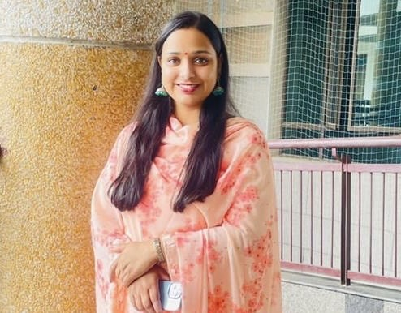 | Designation and Department:  Assistant Professor, Department of Applied Psychology
Education and Training:

Masters of Arts in Psychology (2015) (University of Delhi)
National Eligibility Test-December 2015 Ph.D. Pursuing (2020)
Contact info Email:  Nirupuma.210du@gmail.com | Teaching Experience  6+ years  Areas of Interest  Teaching: Social Psychology, Industrial & Organizational Psychology, Educational Psychology, Child Psychology and Positive Psychology Research: Social Psychology, Positive Psychology, Industrial & Organizational Psychology
Subjects Taught: Industrial & Organizational Psychology, Cognitive Psychology, General Psychology and Counseling Psychology
Research Publications:

- Yadav, N (2018). Why Elderly People Don’t Prefer to Claim Maintenance from their Children? International journal of Indian Psychology, 6(3), DIP:18.01.097/2018060,DOI:10.25215/0603.097

- Gupta,A., Chhabra, M., & Yadav.N. (2019). Spirituality an alternative technique to deal with mental disorders; scoping literature review. Indian Journal of Psychology.

- Ahuja,K.K., Srivastava,G., Padhy,P & Yadav,N.(2019). (Un)easy lies the head that wears the crown: Leadership Selection and Group Performance Among Undergraduate Women. Journal of Organisation & Human Behaviour.

- Gautam,S.,Yadav.,N & Kumar,A.(2019) Role of God and Religion in Healing in Post Disaster Settings. International Journal of Scientific Research and Reviews,8(

Chapter(s) in book(s):

- Yadav, N. (2019) The importance of Psychological Liberation for Women Empowerment. In P.K.Singh & A. Bhowmick (Eds.), Women Empowerment: A Myth or a Reality. (83-93). Delhi, DPH,Delton Publishing House (P) Ltd. (ISBN :978-93-87631-23-6)

- Yadav, N. (2019) Psychological Disorders and Identity Disorders. In U,Bagal., S. Mane, & N. Kolekar (Eds.), Postmodern Perspective in English Language and Literature. Delhi, Authors Press. (ISBN: 978-39-87281-26- 4)

- Yadav,N.(2019) Connection Between Health and Learning. In M. Begum & G. Kumaravelu (Eds.), Wellness Education. School of Education, Pondicherry University.
•

Conferences-Seminars/ Presentations /and Participations:

- Presented a talk on “Menstural Hygeine” at the Coolie Camp, through the NGO , OUTREACH ( 5thApril,2019)

- Yadav, N.(2019) The impact of transformational leadership: a scoping literature review. Paper Presentations at the XXVIII th Annual Convention of the National Academy of Psychology (NAOP), Ramanujan College, New Delhi.

- Gupta,A., Chhabra, M., & Yadav.N. (2019), Spirituality an alternative technique to deal with mental disorders; scoping literature review. Paper presentation at the Ist International Conference on Integrating Traditional Indian Healing Practices with Contemporary Western Health System.

- Had participated in the workshop of Institute of Counsellor Training Research & Consultancy on “School Counselling in the Contemporary Socio-Educational Environment” (April 2017).

- Had participated in the “Brainstorming Session on Youth Development” organized by Ministry of Youth affairs and sports, Government of India on 22nd July 2017.

- Had participated in State Level Awareness Campaign against Sex-Selection and Pre-Birth Elimination of Girl child (2010-2011).

- Had participated in the workshop of Emotional Intelligence (2010).

Administrative Responsibilities:

- Member of the Organizing Committee for One-month Induction Training Program for Faculty in Universities/Colleges/Institutions of Higher Education funded by MHRD & PMMM National Mission on Teachers and Training (22May-21st June 2019).

- Member of the Editorial board for the Ramanujan College Magazine, “Alok Tirtha” (2018-2019)

- Member of the Organizing Committee at the XXVIII th Annual Convention of the National Academy of Psychology (NAOP), Ramanujan College, New Delhi (December 2018)

- Member of the Women Development Cell, Ramanujan College (2018-till date)

- Member of the OUTREACH, NGO (2018-till date)

- Member of the Psychology Union at Lady Shree Ram College, University of Delhi (2017-18)
Any Link for Detailed CV (ex: Google Drive link)
Any Other (as per requirement)

- Former Intern at Child Welfare Committee, Department of Women and Child Development, Government of NCT, Delhi, sewa kutir complex, Kingsway Camp, Delhi (23rd may – 20th july, 2014)

- Worked as PGT(Psychology)/ Counsellor at DLF Public School, Shaibabaad, Ghaziabaad ( 11th January2016- 10 September 2016)

- Worked as a School Counsellor at Darshan Academy, Delhi (19th September – 31stMay 2017.)

- Worked as Assistant Professor at Lady Shree Ram College, University of Delhi for the academic session 2017- 2018

- Working as Assistant Professor at Ramanujan College, University of Delhi till date

