Sheetal Singh
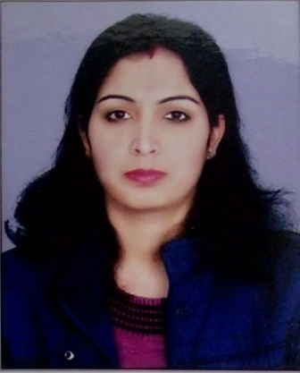 | Assistant Professor  Department of Computer Science
 | B.Sc(H) Computer Science, MCA
Contact info  Mobile: 9871012362  Email: sheetal.2109@yahoo.in | Teaching Experience: 5 years  Areas of Interest  Teaching: Database Systems, Operating Systems, Computer Networks  Research: Neural Networks, Artificial Intelligence
Subjects Taught:
Computer Networks, Database Management Systems, Software Engineering, Programming Fundamentals using C++, Operating Systems, Computer Graphics
Research Publications:
1. Privacy preserving approach for VANETs using Mutation technique of genetic algorithm
2. Big Data and Cloud Computing: Challenges and Opportunities
3. Software Defined Networking: Architecture, Applications and Challenges
Other Academic Publications
Conferences-Seminars Presentations and Participations:
1. Participated in UGC sponsored National Conference on Recent Statistical Computing Techniques and their Applications
2. Participated in Faculty Development Programme on Computational , Mathematical and Statistical Techniques
3. Attended a workshop on Information Technology in ILLL
Administrative Responsibilities:
1. Member of Placement Cell of the College
2. Member of Core committee of DDU Kaushal Kendra
3. Member of Annual Fest – Josh Committee
4. Member of Website Development Committee
Any Link for Detailed CV (ex: Google Drive link)
Any Other (as per requirement)

