Name of the Faculty: Ms. Ramya Jain

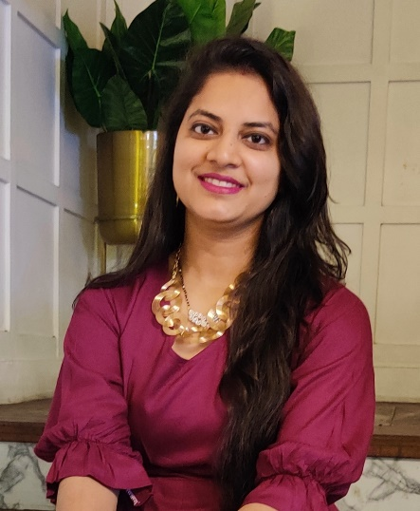 | Designation and Department:  Assistant Professor, Department of Commerce
Education and Training

- Pursuing Ph.D from Department of Commerce, University of Delhi.
- M.Phil. in Accounting, Department of Commerce, Delhi School of Economics in 2019.
- M.Com., Motilal Nehru College, University of Delhi in 2015.
- B.Com. (Hons), Lady Shri Ram College for Women, University of Delhi in 2013.

Contact info  Mobile: +91-9999020438  Email: ramya.jain1990@gmail.com | Teaching Experience: 8 Years.  Areas of Interest:  Teaching: Finance and Accounting  Research: Finance, Accounting
Subjects Taught:

Management Accounting, Business Law, Business Statistics, Business Environment, Foreign Exchange Management, Financial Management, Financial Markets and Institutions, Advertising and Personal Selling.

Research Publications

- Jain, R. (2019). Impact of Human Resource Accounting on Firm’s Value. Indian Journal of Accounting, 51(2), 53-60. ISSN 09721479
- Jain, R. (2017). Human Resource Accounting Methods: A Literature Review. International Education & Research Journal, 3(6), 156-158. ISSN 24549916
- Jain, R. (2017). Human Resource Accounting Advantages, Issues and Practices in India: A Literature Review. International Journal of Innovative Research and Advanced Studies, 4(5), 404-408. ISSN 23944404
- Jain, R. (2017). Brand Personality and Brand Loyalty. International Journal of Research in Commerce & Management, 8(6), 43-45. ISSN 09762183
- Jain, R. (2017). Major Branding Decisions and Strategies. International Journal in Management and Social Science, 5(5), 366-371. ISSN 23211784
- Jain, R. (2017). Basic Branding Concepts: Brand Identity, Brand Image and Brand Equity.
International Journal of Sales & Marketing Management Research and Development, 7(4), 1-8. ISSN 22496939
Conferences-Seminars Presentations and Participations:

- Presented and won the “Best Paper Award” for Research Paper titled “Impact of Human
Resource Accounting on Firm’s Performance” in 42nd All India Accounting Conference & International Seminar on Accounting Education and Research organized by Indian Accounting Association, Jodhpur in December 2019.
- Participated in the National Faculty Development Programme on “Goods and Services Tax” organized by Teaching Learning Centre, Ramanujan College, University of Delhi in association with Indian Accounting Association, NCR Chapter held on October 27, 2017.
- Participated in the 1st Conclave of Ethicists and Educationists on the theme “Role of Universal Ethics in Higher Education Teaching” jointly organized by Tibet House, Cultural Centre of His Holiness the Dalai Lama and the Centre for Ethics and Values, Ramanujan College held on April 21, 2017.
- Participated in the Knowledge Sharing Program on “Enhancing Experiential Learning in Teaching Through Innovative Methods” organized by IBS Business School, ICFAI Group on July 30, 2016.
- Participated in the 10th National Programme on “Project Management” organized by the Strategic Management Group, supported by the Ministry of Statistics & Programme Implementation, Govt. of India held on June 23-25, 2016.
- Participated in the Faculty Development Programme on “eCognitio: An Innovative Elearning Workshop Promoting Student Participation and Collaborative Learning” organized by Kamala Nehru College, University of Delhi on May 23, 2016.
- Participated in the Faculty Development Programme on “How to master the stock market” conducted by the BSE Institute Limited, Delhi on April 22-23, 2016.
- Participated in the UGC sponsored National Conference on “Marketing in 21st Century: Issues and Challenges” organized by Shaheed Bhagat Singh College, University of Delhi on February 5-6, 2016.

Administrative Responsibilities:

- Convenor of FinJan- The Finance and Investment Cell, Ramanujan College (2023 onwards).
- Convenor of Brushstrokes- The Arts Society, Ramanujan College (2022-24).
- Active member of Ramanujan College’s Dance Society, DNA, 2017 till date.
- Active member of Ramanujan College’s Quiz Society 2017-2019.
- Active Member of Commerce Society RamComm, Ramanujan College, 2016-2019.
- Co-ordinator of Ignite, Business Games, Quiz and Debating Society, Department of Management Studies, Ramanujan College, 2016-2018.
- Active member of Ramanujan College’s Website Committee, 2017-2018.
- Active member of Ramanujan College’s Sports Committee, 2016-2018.
- Active Member of Placement Cell of Ramanujan College, 2016-17.

Any Other (as per requirement)

- Resource Person, 1-month Faculty Induction/Orientation Programme organized by Teaching Learning Centre, Ramanujan College.
- Resource Person, 2-week Faculty Development Programme organized by Department of Management Studies, Ramanujan College.
- Member of the organizing team of 5th International Conference on Ethics entitled “Social Responsibility: The Ethical Dimensions” jointly organized by the Centre for Ethics and Values and Department of Commerce, Ramanujan College, University of Delhi on March 12-13, 2016.
- Secured First Position in Motilal Nehru College, University of Delhi in M.Com 2013-15.
- Secured First Position in Lady Shri Ram College for Women, University of Delhi in B.Com Hons. 2011-13.

