Name of the Faculty: Ms. Inakshi
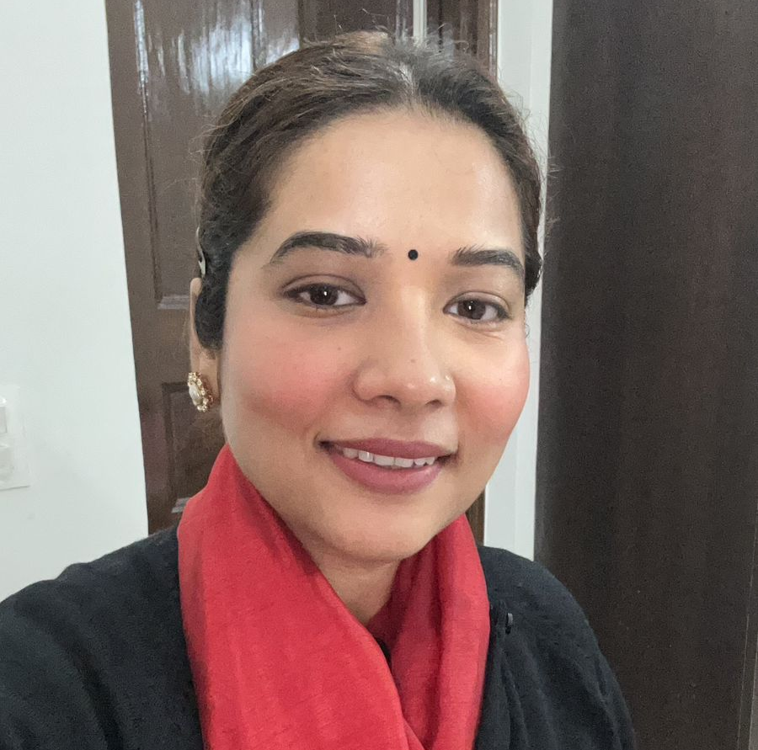 | Designation: Assistant Professor  Department: Commerce
Education:
B.Com(H)
MBA
Contact info:  inakshi@ramanujan.du.ac.in  9971563601  https://www.linkedin.com/in/inakshi/ | Teaching Experience: 7 years  Areas of Interest  Teaching:  Digital Marketing  Core Marketing concepts  Production and operations management  Research:  Marketing  Advertising  Nutrition
- Subjects Taught:
1. Production and Operations Management
2. Digital Marketing
3. Principles of Marketing
4. Entrepreneurship and New Venture Creation
5. India's Diversity and Business
6. Performance and Compensation Management
7. Business Ethics and Corporate Governance
8. IT Tools for Business
9. Statistical Software Package (SPSS)
10. Business Research
11. Company Law
12. Finance for everyone

Research:

Publications:
- Inakshi, 2017, INDIAN DEMONETISATION: A REVIEW OF THE 2016 FINANCIAL HIJACK OF THE INDIAN ECONOMY, INSPIRA- Journal of Modern Management and Entrepreneurship (JMME) Volume: 07 No. 03., Impact Factor of the Journal-2.0546 (45138).
- Inakshi, 2017 ,MENTORING’S IMPACT ON LEADER EFFICACY DEVELOPMENT, INSPIRA- JOURNAL OF COMMERCE, ECONOMICS &amp; COMPUTER SCIENCE ,Volume 03,No. 02,. Impact Factor of the Journal-2.0546 (48314).
- Inakshi, 2017,START-UP INDIA: STRATEGIES, OPPORTUNITIES AND CHALLENGES, INSPIRA- Journal of Modern Management and Entrepreneurship (JMME) Volume 07, No. 04, Impact Factor of the Journal-2.0546 (45138)
- Inakshi - “SOCIAL IMPACT OF FOOD ADVERTISING: A STUDY”,PEZZOTTAITE JOURNALS,International Journal of Applied Services Marketing Perspectives ,Volume 6, Number 2, Impact Factor of the Journal-(47673).
- Inakshi and Deepti Gupta, 2017,SOCIAL MEDIA MARKETING: A REVIEW ON TRENDS, DIRECTIONS &amp; DIFFUSION”, INSPIRA- JOURNAL OF COMMERCE, ECONOMICS &amp; COMPUTER SCIENCE ,Volume 03,No. 02,Impact Factor of the Journal-2.0546 (48314)
Research Guidance

None
Books/Chapter:

Human Resource Management (English, Hardcover) by Dr. Sangeeta Mohan and Ms. Inakshi

Conferences-Seminars Presentations and Participations:
International Conference on Advances in IoT, Security with AI
Program Committee Member
Deen Dayal Upadhyaya College, University of Delhi

Annual International Commerce Conference on भारत @ 2047: Role of Commerce and Business
Program Committee Member
Deen Dayal Upadhyaya College , University of Delhi

National Seminar on Contemporary Strategies for Sustainable Development: Marketing and HR
Program Committee Member
Deen Dayal Upadhyaya College , University of Delhi

International Conference on Global Vision 2030: Challenges and Opportunities
Delegate
Deen Dayal Upadhyaya College , University of Delhi

Any Other (as per requirement)

