Ramanujan College
FACULTY PROFILE
FIRST NAME | MS. VINEETA |  | MIDDL  E NAME  (if any) |  |  | PHOTOGRAPH (ATTACH BELOW)
LAST NAME | CHAUDHARY |  |  |  |  | 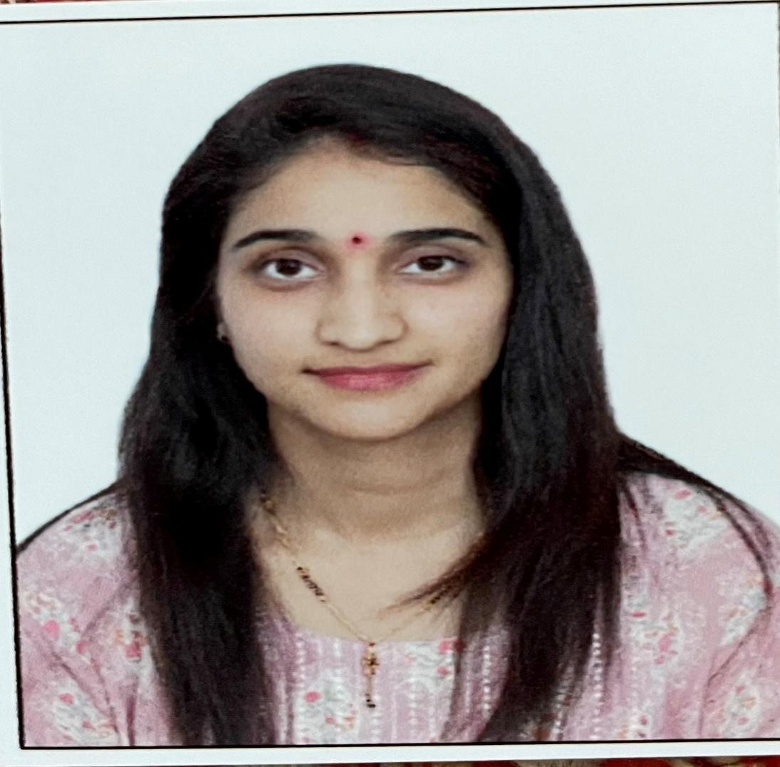
DEPARTMENT | COMMERCE
DESIGNATION | ASSISTANT PROFESSOR
GENDER | FEMALE
DATE OF  BIRTH  (DD/MM/YYYY  ) | 20/03/1994
LANGUAGE  PROFICIENCY | HINDI, ENGLISH
ADDRESS | VILLAGE GHITORNI NEW DELHI-110030
MOBILE | 8745003443
EMAIL | Vineeta.chaudhary12@gmail.com
EDUCATIONAL QUALIFICATIONS:
DEGREE |  | INSTITUTION |  |  | YEAR
B.Com | University of Delhi | 2015
M.Com | IGNOU | 2017
NET | UGC | 2017
CAREER PROFILE: TEACHING EXPERIENCE
4.5 Years of Teaching Experience
ADMINISTRATIVE ASSIGNMENTS: (List any administrative roles or responsibilities you have held)
AREAS OF INTEREST / SPECIALIZATION: (Highlight your specific areas of interest or fields of specialization within your subject area)
HRM and Marketing
SUBJECTS TAUGHT: (List all the subjects you have taught)
Financial Accounting, Organisational Behaviours, Business Environment, Fundamentals of Management etc.
COURSE DEVELOPMENT: (Mention any courses you have developed or contributed to designing)
PUBLICATIONS PROFILE: RESEARCH PAPERS (List your published research papers, including the title, journal, and year)
1-VINEETA CHAUDHARY,” External influences Effect on young consumers buying actions with respect to apparel industry in Delhi city” International Research Journal of Management and Commerce ISSN: (2348-9766) Impact Factor 7.001 Volume 9, Issue 03 March 2022
2-VINEETA CHAUDHARY,“A study for Indian Consumers depicting significant impact of Consumer Trust on their online purchasing habits” INTERNATIONAL RESEARCH JOURNAL OF COMMERCE, ARTS AND SCIENCE ISSN: (2319 – 9202) Volume 13 Issue 7 [Year -
2022]
3-VINEETA CHAUDHARY,“A study on the impact of pandemic of consumer behaviour” INTERNATIONAL RESEARCH JOURNAL OF
COMMERCE, ARTS AND SCIENCE ISSN: (2319 – 9202) Volume 13 Issue 6 June 2022

C
ONFERENCE / WORKSHOPS/ REFRESHER/ FDP/ TRAINING ORGANIZED
1.Organising team member of National Seminar on Women in Bhartiya Discourse organised by ABISYS in collaboration with Centre for Hindu Studies, Ramanujan College and ICPR, University of Delhi.
2. Organising team member of 8 days NEP: Orientation & Sensitization Program organised by MMTTC,Ramanujan College in collaboration with Dr. Bhim Rao Ambedkar College, University of Delhi

CONFERENCE/WORKSHOPS/TRAINING ATTENDED AS FACULTY MEMBER
- Two week Faculty development program on “Indian Knowledge System: A Multidimensional Legacy” under Teaching Learning Centre, Ramanujan College University of Delhi in Collaboration with Shyama Prasad Mukherji College for Women, University of Delhi.
- 4-Week Faculty Induction/Orientation Program under Teaching Learning Centre, Ramanujan College, University of Delhi in Collaboration with Dhote Bandhu Science College, Gondia, Maharashtra.
- One day National Workshop on “Brain Balancing and Hypnosis organized by Ramanujan College University of Delhi, Department of Mathematics.
- NEP2020:Pedagogical Imperatives of Higher Education, University of Delhi, Multipurpose Hall DU, Dec. 01,2023
- The Relevance of Bharatiya Gyan Parampara in Management, Department of Commerce Ramanujan College University of Delhi, Ramanujan College, Nov. 7,8 2023
- Unlocking the Potentials of AI in Teaching Pedagogy, Jaipuria Institute of Management, Noida, 3rd Nov. 2023
- Workshop on “Role of Teachers in Higher Education” organized by Department of Commerce Ramanujan College
- Attended hybrid refresher course in Ramanujan College on Revisiting the Past: New Perspectives through interdisciplinary Approaches

INVITED LECTURES AS RESOURCE PERSON AND PAPER PRESENTATIONS:
AWARDS AND DISTINCTIONS:

VALUE ADDED COURSES

