Name of the Faculty: Mrs. Charu Jain
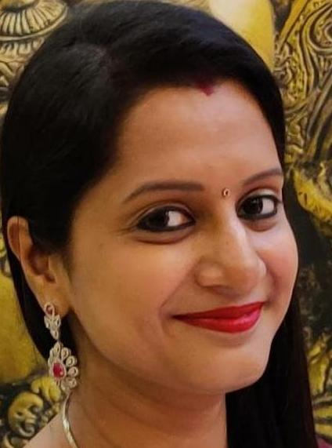 | Designation : Assistant Professor  Department : Department of Commerce
Education and Training
Pursuing Ph.D, MBA (Finance) and B. Com. (H)
Contact information  Mobile: 9953993958  Email:  jain.charu1988@gmail.com | Teaching Experience: 11 years of teaching experience  Areas of Interest  Teaching: Financial Management and Direct Tax  Research: Finance
Subjects Taught:

Income Tax Law & Practice
Financial Management
Advertising and Personal selling
Cost Accounting
Management Accounting
Research Publications: Published Research papers with below title in renowned International Journals:
- Succession Management
- Stress Management
- Need and Importance of Strategic Human Resource Management
- Relevance of Ethical Values in Education
Conferences-Seminars Presentations and Participations:

- Attended One Day National Workshop on Brain Balancing and Hypnosis organized by Department of Mathematics, Ramanujan College on 13th October 2023.
- Attended two weeks Refresher Course in “Commerce” from 31st July to 14th August 2023 organized by Teaching Learning Centre and Department of Commerce, Ramanujan College University of Delhi in collaboration with SST College of Arts and Commerce, Ulhasnagar, Maharashtra under the aegis of Ministry of Education Pandit Madan Mohan Malaviya National Mission on Teachers and Teaching.
- Attended two weeks Interdisciplinary Refresher Course on “Research Methodology and Data Analysis” from 21st February 2022 to 5th March 2022 organized by Teaching Learning Centre, Ramanujan College University of Delhi under the aegis of Ministry of Education Pandit Madan Mohan Malaviya National Mission on Teachers and Teaching and Indian Accounting Association, NCR Chapter.
- Attended One day Faculty Development Programme on “How to Write Quality Research Papers and Get Published in High Indexed Journals” on 28 January, 2022 organized by Acharya Bangalore B School.
- Participated in International Conference on Innovations and Sustainable Practices in Commerce, Management and Social Sciences: Future Prospects and Challenges conducted by Maniben Nanavati Women’s College Mumbai and Inspira Research Association –IRA, Rajasthan on 4th and 5th June 2021.
- Participated in International Conference on Managing Inflection Point in Changing Landscape: Through Technological Innovations in IMS Ghaziabad on 24th April 2021.
- Attended Two Days International Virtual Conference on “World Economic Resilience –Gearing for a better Future” conducted on April 9th-10th, 2021organized by St. Joseph’s College of Commerce, Affiliated to Bengaluru City University.
- Attended 14 days National Faculty Development Programme on Data Analysis for Research in Social Sciences conducted by Ramanujan College under Ministry of Human Resource Development, Pandit Madan Mohan Malaviya National Mission on Teachers and Teaching from 17th June 2020 to 30th June 2020.
- Attended "Workshop on Research Paper Writing and Publication in Quality Journals (Scopus/WOS/ABDC/UGC-CARE)" organized by Bharati Vidyapeeth (Deemed to be University) Institute of Management and Research, New Delhi, from 9th May 2020 to 10th May 2020.
- Attended Two Weeks Faculty Development Programme on "MANAGING ONLINE CLASSES and CO-CREATING MOOCS" From April 20 - May 06, 2020 under Pandit Madan Mohan Malaviya National Mission On Teachers and Teaching, Ministry of Human Resource Development (MHRD) at Ramanujan College, University of Delhi.
- Attended Seven Days Faculty Development Programme on Teachers, Teaching and Taught: Discovering New Meanings, Relationships and Purpose organised by Internal Quality Assurance Cell and Teaching Learning Centre, Ramanujan College, University of Delhi from 1-7 January, 2020.
- Attended Seven Days Faculty Development Programme on “Research Methodology and Statistical Tools” under Pandit Madan Mohan Malaviya National Mission On Teachers and Teaching, Ministry of Human Resource Development (MHRD) held from December 23- 29 (2019) at Ramanujan College, University of Delhi.
- Attended One Day Faculty Development Programme on “Financial Accounting and Income Tax Laws” under Pandit Madan Mohan Malaviya National Mission On Teachers and Teaching, Ministry of Human Resource Development (MHRD) held on 30th August,2019, at South Campus, University of Delhi organized by Teaching Learning Centre, Ramanujan College, University of Delhi.
- Attended 4 week “Induction Training Programme for faculty in Universities/Colleges/Institutes of Higher Education” conducted by the Teaching Learning Centre, Ramanujan College, University of Delhi from 9th April to 5th May 2018.
- Attended UGC Sponsored National Conference on “Leadership in Organizations: Contemporary Concerns and Key Developments” organized by Department of Management Studies and Teaching Learning Centre, Ramanujan College, University of Delhi on 22-23 March 2018.
- Attended Seven-day FDP on “Skill based Teacher’s Training in ICT, IPR and Research “organized by Teaching Learning Centre , Ramanujan College, University of Delhi from 5-11 March 2018.
- Attended one week National Faculty Development Programme on “Reflections on Emerging Pedagogy in Higher Education and Qualitative Research”organized by Department of Commerce, Ramanujan College, University of Delhi from November 18 -24, 2015.
- Attended one week Faculty Development Programme on “Leveraging Research Tools for Quality Research” organized by Department of Financial Studies, University of Delhi; Ramanujan College, University of Delhi and Indian Accounting Association, NCR Chapter at University of Delhi, South Campus from June 15-21,2015.
- Attended conference on “National Conference on Emerging Trends and Contemporary Issues in Finance and Marketing” organized by the Department of Commerce, Ramanujan College, University of Delhi on 8th April 2015.
- Attended Faculty development Programme on E-Filing of Return.
- Actively Participated in International Seminar on Management Skills.

Administrative Responsibilities:

• In-charge of NAAC related work of the Department of Commerce.
• Co-convenor of Jazba Theatre Society.
• Member of Website content management committee.
• Member of the Webinar Committee of the Department of Commerce.
• Member of the Outreach Program Committee of Department of Commerce.
• Member of Ramcomm Society-Department of Commerce.

